IT 295

CAPSTONE PROJECT

March 29, 2021

ENSIGN COLLEGE

Dear Brother Morrill,

Enclosed is the Executive Summary on the work I did for my Final Capstone Project just as we discussed before. Feel free to contact me if you have any questions.

Sincerely,

Adriana Silveira

Executive Summary: What is the ‘business’? 3

Part 1 – Understanding the Permanent Labor Certification Program (PERM) 4

Why it matters 5

The Dataset 5

Questions to be answered 5

Part II – Preparing for Analysis 6

Selecting the Dataset 6

ETL process 6

Preparing Data 8

Getting additional source tables 9

Part III – Analysis and Results 9

Part IV – Visualizations 13

Part V - Conclusions 17

Appendix 17

 17

Sources 18

## Executive Summary: What is the ‘business’?

Every data analysis has (or should have) a goal. Businesses and people can be benefited from information they can pull up from data, but it is crucial to understand the data and to have clear questions to be answered. In the context of this paper, the goal is to help people that are holding non-immigrant visa types, or still or their home countries planning move to the USA. The dataset that was analyzed contain data on the PERM Program. This program is the first step that can lead to a green card, and further to citizenship. This is huge for people that, like me, want to live legally in this country and actively contribute to the workforce and economic development – while allowing development for ourselves and our families as well.

This work will explain what PERM means, why it matters, what are the questions that can be answered through the selected dataset, and finally and more importantly, provide the conclusions that can be valuable for those whose ‘business’ or interest is to apply for a green card hopefully become Permanent Residents in USA.

# Part 1 – Understanding the Permanent Labor Certification Program (PERM)

The Permanent Labor Certification Program is a certification issued by the U.S. Department of Labor (DOL). The certification means that U.S. employer searched for U.S. workers to fill the position, however they didn’t find candidates, either because workers are not able, willing, qualified, or available to take the job. The goal of this program is to ensure that the employment of a foreign worker will not negatively impact wages and working conditions of employed U.S. workers in similar positions.

Once the DOL issues the certification PERM, the employer can then submit an application to the Department of Homeland Security's [U.S. Citizenship and Immigration Services (USCIS)](https://www.uscis.gov/portal/site/uscis) that will process the immigration petition. The certification PERM is valid for 180 days, and in case the employer does not submit the petition to USCIS within this period, it will expire.

## Why it matters

PERM is the first step in the process of getting a permanent resident status (green card) based on employment. Without a certification of labor (PERM) an employer can’t submit an Immigrant Petition for Alien Worker to the Department of Homeland Security's [U.S. Citizenship and Immigration Services (USCIS)](https://www.uscis.gov/portal/site/uscis). Therefore, this information is really relevant for people interested in being sponsored by an employer to get a green card.

## The Dataset

The main dataset used for this analysis is found at <https://www.dol.gov/agencies/eta/foreign-labor/performance> and it contains data from the most recent fiscal year (10/2019 – 09/2020). Additional tables were needed to help understand the meaning of terms contained in the main dataset such as SOC (Standard Occupational Classification) and NAICS (North American Industry Classification System).

## Questions to be answered

1. How many PERM applications were filed in the fiscal year 2020? What are their statuses?
2. How long in average it took for a decision to be made (processing time)?
3. Which are the most common occupational areas related to PERM applications (Standard Occupational Classification)?
4. What is the average wage by occupational area?
5. What is the distribution of applications according to excepted salary range?
6. What are the Top 20 Employers applying for PERM and what are their Industries/time in Business/number of employees?
7. In which US states are the workplaces located?
8. What are the main Attorney Offices and their approval/denial rates?
9. Who are the most common citizenships of applicants (their home countries/previous immigration status/level of education)?

# ****Part II – Preparing for Analysis****

## ****Selecting the Dataset****

**The dataset was found in the official government website** <https://www.dol.gov/agencies/eta/foreign-labor/performance>**. Although other public websites contain data on the topic, I decided to go to the official source to preserve data reliability and integrity. I decided to work with the most current table from the fiscal year of 2020 (October/2019 to September/2020).**

## ****ETL process****

**I used the SQL Server Import and Export Wizard to get the Excel file downloaded from the source to a new database I created inside SQL Server. During the ETL process I got the following error:**

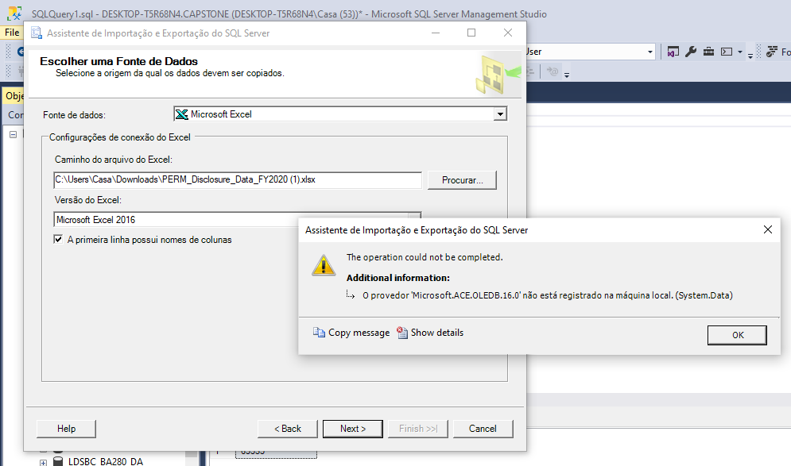

**I did a research on Google on this error and tried one of the troubleshooting which was converting the** .xlsx file to .xls file and then was able to finish the importation process. However, I realized that the number of total rows imported was not the same as on the source file. I researched more and found out I needed to install a specific tool to Excel. I did the download and install and was able to complete the ETL process successfully. I did inquiries to the new table imported checking the number of total rows and columns and assured the ETL was done successfully.

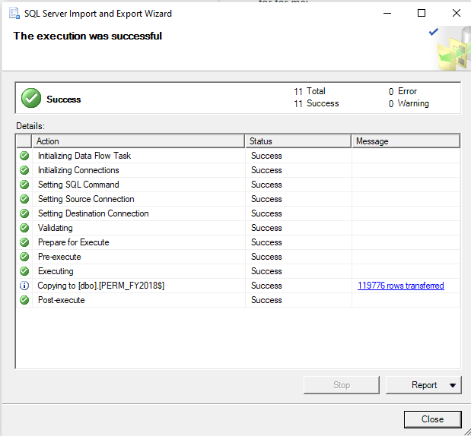

**.**

## ****Preparing Data****

**I wrote a script that created a new table from the original table source while doing some modifications. A new column was added as a PK (INDEX) to facilitate analysis. The previous PK was the Case Number, not to friendly to be used in queries. Also, the number of columns was reduced from 154 to 32. In this process, I** analyzed the table layout and field descriptions **provided by the same website (attached to this document as an Appendix). By reducing it dramatically, the number of columns I could keep only the data I would need to answer my questions and also improve SQL performance in my Queries.**

## ****Getting additional source tables****

**My main source table uses a code from Standard Occupational Classification (SOC) to identify the occupation related to the application. Therefore, I needed a source that would give me the description of the occupation, and also aid me during the analysis process. I got the table from** <https://www.bls.gov/soc/2018/home.htm> website and imported to my database also using **SQL Server Import and Export Wizard. In order to facilitate further analysis, I create a view (virtual table) to combine results from both source tables.**

**A second table source needed contains definition of NAICS (North American Industry Classification System) and was used to clarify the title of the industries each employer declares, once the original data sources showed only the codification.**

# ****Part III – Analysis and Results****

**The analysis tool used for the analysis was Tableau. I connected the data and configured the relationships between the tables and views. All the questions I determined before were answered through the data. Questions and answers are displayed in this Part III and the visualizations are shown on Part IV.**

1. How many PERM applications were processed in the fiscal year 2020? What are their statuses?

Total cases: 94,019

Certified: 53,714 (57.13%)

Certified-Expired*: 32,342 (34.40%)

Denied: 4,213 (4.48%)

Withdraw: 3,750 (3.99%)

* Certified-Expired status indicates that the PERM was approved but the employer did not fill a petition on USCIS to further the immigration process within 180 days.

1. How long in average it took for a decision to be made (processing time)?

The average processing time was 165.4 days (about 5.5 months)

1. Which are the most common occupational areas related to PERM applications (Standard Occupational Classification)?

The two most common occupational areas are: Statisticians and Electronic Engineers (11% each). Other common occupational areas are also related to Engineering such as: Mechanical Engineers (7%), Electrical Engineers (4%), Industrial Engineers (4%). Analysts are also common occupations: Financial and Investments Analysts (5%), Management Analysts (5%), Market Research Analysts (4%).

1. What is the average wage by year?

The average wage by year is $131,555 among all the occupational areas.

1. What is the distribution of applications according to excepted salary range?

The majority of the applications fall into the range between 90K to $120K a year (35% of the total).

1. What are the Top 20 Employers applying for PERM and what are their Industries/time in Business/number of employees?

The top 20 U.S. employers searching for foreign workforce are larger companies and well-known companies. We can list some of them:

Google, Microsoft, Amazon, Facebook, Intel, Apple.

Some of the top Industries:

Computer Programming Service; Electronic Computer Manufacturing; Data Processing, Hosting and Related Services; Computer Systems Design Services.

Their average time in business is in the range of 18-50 years (excluding the outlier JP Morgan Chase CO with 222 years in business.

The number of employees of the largest company (Amazon) is 647K, the lowest number of employees is 11K (LinkedIn) and the average is 141,562 employees.

1. In which US states are the workplaces located?

Almost 25% of all the workplaces is in California.

In second place we find Texas, with 11.25%.

New York and Washington states together sum up 16.2% of the workplaces.

1. What are the main Attorney Offices and their denial rates?

|  |  |
| --- | --- |
| **AGENT_ATTORNEY_FIRM_NAME** | **Denial Ratio %** |
| NULL | 22,25% |
| Ogletree, Deakins, Nash, Smoak Stewart, P.C. | 18,05% |
| Erickson Immigration Group | 3,51% |
| Fragomen, Del Rey, Bernsen Loewy LLP | 3,48% |
| Fragomen, Del Rey, Bernsen Loewy, LLP | 1,39% |
| EY Law LLP | 1,25% |
| Berry Appleman Leiden LLP | 1,01% |
| Fakhoury Global Immigration, USA PC | 0,96% |
| Tafapolsky Smith Mehlman LLP | 0,68% |
| Sidley Austin LLP | 0,63% |

We see by the chart above that not having an attorney firm is not a good idea. The percentage of denial for applications without an attorney is 22.25%. Among the attorney firms, the highest denial rate is for the firm Ogletree, Deakins, Nash, Smoak Stewart, P.C. (18.05%)

1. Who are the most common citizenships of applicants (their home countries/previous immigration status/level of education)?

78.47% of prospective employees have either a bachelor’s or a master’s degree. 65.30% of them hold a H-1B visa. And the large majority comes from India (49.11%) followed by China (12.65%).

# ****Part IV – Visualizations****

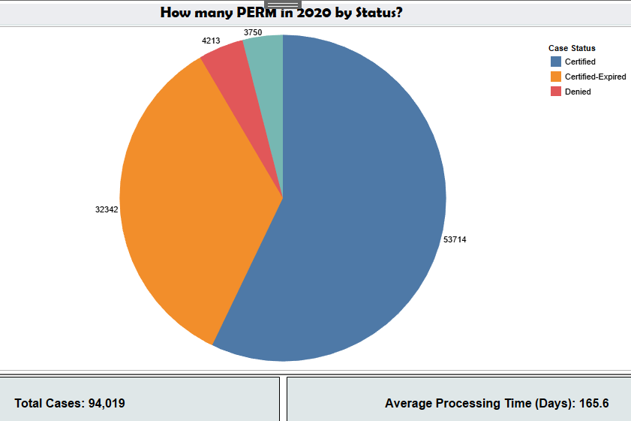

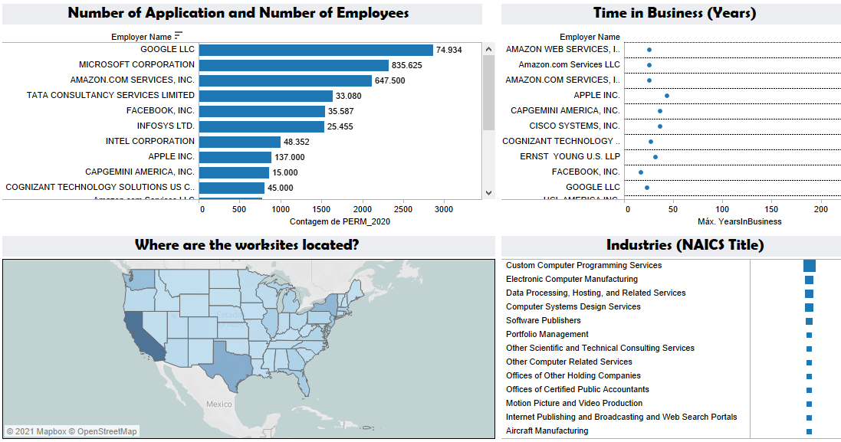

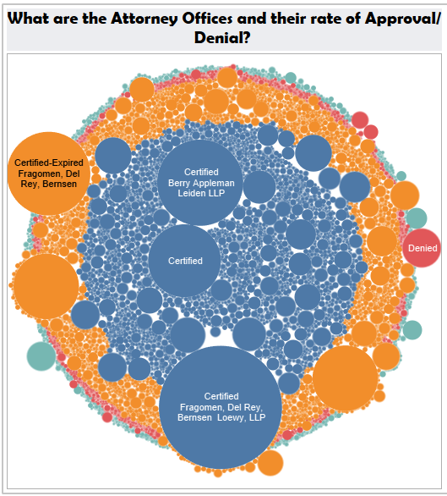

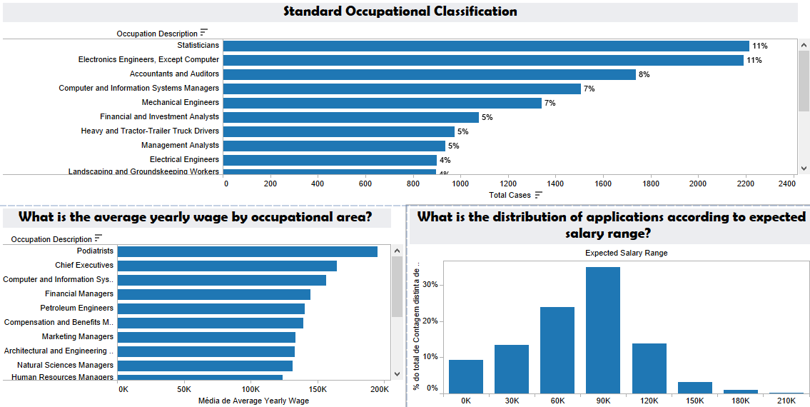

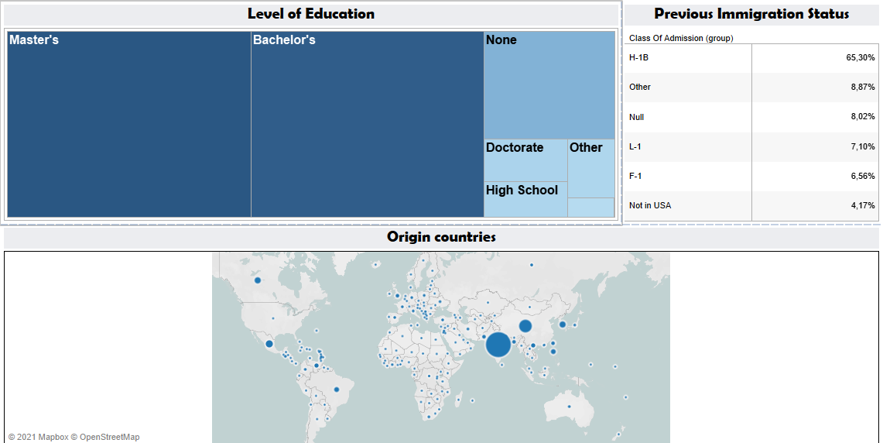

# ****Part V - Conclusions****

**PowerPoint topics:**

**Business Perspectives: every time we are looking into data of any sort we need to have the right perspective in mind. If we are a business for example, we need to think why this data is important, how can I use it to guide my decisions and reach my business goals. In this case, I looked into the data with the perspective of a foreign that wants to live legally in USA contributing to the development of the country through a work visa, and get a green card.**

# Appendix

This is the Layout for the source table. It explains in detail about the information stored in each one of the 158 columns..

# 

The report is attached to the assignment as a second file.

## Sources

https://www.dol.gov/agencies/eta/foreign-labor/programs/permanent

https://www.dol.gov/agencies/eta/foreign-labor/performance

<https://www.bls.gov/soc/2018/home.htm>

https://www.census.gov/eos/www/naics/downloadables/downloadables.html